A good cell model?

Some children were asked to make models of cells.
A | B
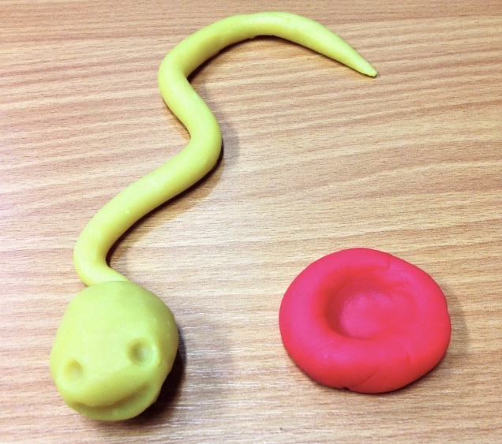 | 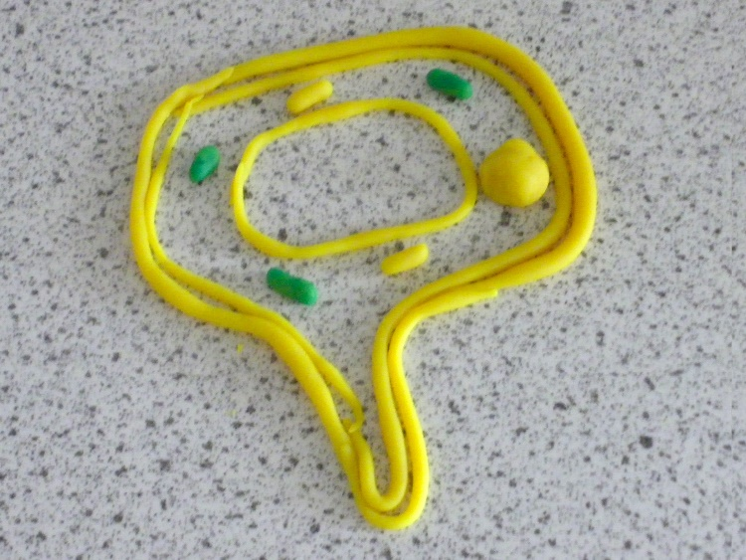
C | D
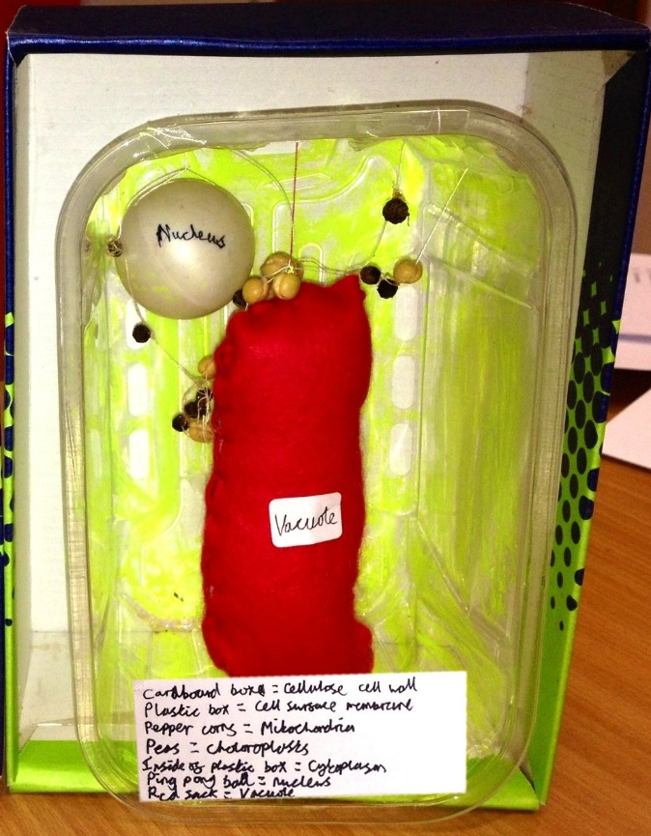 | 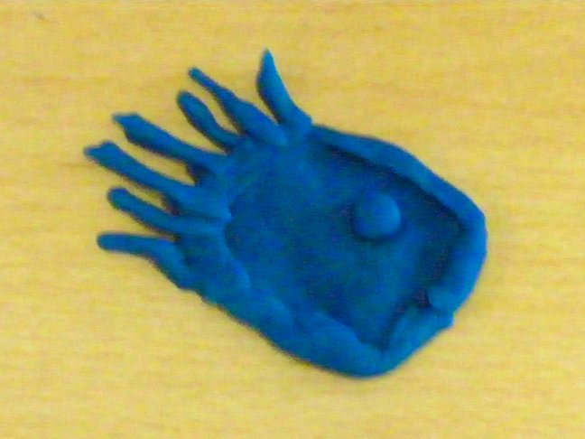

- Which is the best model of a cell?
- How would you explain your answer to question 1?

Biology > Big idea BCL: The cellular basis of life > Topic BCL1: Cells > Key concept BCL1.3: Cell shape and size
Diagnostic question
A good cell model?

Overview
Learning focus: | Cells are usually too small to be seen without a microscope, but have a range of three-dimensional shapes and sizes.
Observable learning outcome: | Apply the idea that cells have a three-dimensional shape.
Question type: | Two-tier multiple choice
Key words: | cell

What does the research say?
Research has shown that students at age 11-14 resist accepting that cells are three-dimensional object, believe instead that they are flat (Vijapurkar, Kawalkar and Nambiar, 2014).
Clément (2007) notes that the cell concept is generally introduced by two, two-dimensional, cross-sectional line drawings, comprising a plant cell that is generally polygonal and adjacent to other cells and an animal cell that is more rounded in shape and isolated. Clément has dubbed the common depiction of an animal cell as two concentric circles (cell membrane and nucleus, lacking other organelles or internal structures) the “fried-egg model”. If students are not presented with a greater variety of images of cells they may come to think that all animals cells and all plants cells have the same shape and structures as these two archetypal depictions; Clément found exactly this misunderstanding persisting in students up to undergraduate level.
Several studies have advocated the building and use of three-dimensional models of cells during teaching to help overcome this (e.g. Tregidgo and Ratcliffe, 2000; Lazarowitz and Naim, 2014).
Ways to use this question
Students should complete the questions individually. This could be a pencil and paper exercise, or you could use the PowerPoint presentation with an electronic voting system or mini white boards.
The answers to the questions will show you whether students appreciate that cells have a three-dimensional shape, and that a good model would represent the three-dimensional nature of cells rather than the two-dimensional nature of typical textbook cell diagrams.
Differentiation
You may choose to read the questions to the class, so that everyone can focus on the science. In some situations it may be more appropriate for a teaching assistant to read for one or two students.
If students choose to focus on aspects of aesthetics or artistic merit when answering question 2, prompt them to considering the following:
- What makes each model a good representation of a cell?
- In what ways could each model be misleading?
Expected answers
C | 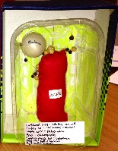 | The model shows the cell and the subcellular structures as three-dimensional. All of the common features of a plant cell are represented, including cell wall (the cardboard box), cell membrane (plastic tub), nucleus (ping pong ball), vacuole (red sack), chloroplasts (peas) and mitochondria (peppercorns). All of the structures are labelled.
How to respond - what next?
B | 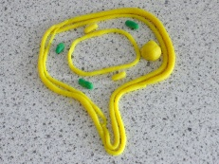 | The student has, in effect, built a three-dimensional model of a two-dimensional line drawing. The student is sticking too closely to the archetypal plant cell model as depicted in textbooks, even going so far as to include chloroplasts (as a typical plant cell feature) in a root hair cell that would not have them (because it is found underground where there is no light).

A | 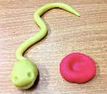 | These models show a wider variety of cell types than the archetypal animal cell model depicted in textbooks (a sperm cell, a red blood cell, and a goblet cell), and an attempt has been made to show the three-dimensional nature of these cells. However, they lack detail, and the sperm cell has been given facial features, which demonstrates an animistic or anthropomorphic view of cells and misunderstanding of the size and scale of cells.
D | 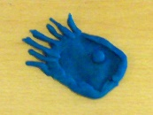
You may choose to respond through structured class discussion. Ask one student to explain why they gave the answer they did; ask another student to explain why they agree with them; ask another to explain why they disagree, and so on. This sort of discussion gives students the opportunity to explore their thinking and for you to really understand their learning needs. Responses often work best when the activities involve paired or small group discussions, which encourage social construction of new ideas through dialogue.
If students have misunderstandings about the three-dimensional nature of cells, it may be helpful to ask students to work in groups to build their own models of cells, with an emphasis on group discussion to decide how the model should look. The following BEST ‘response activity’ describes just such as activity and could be used in follow-up to this diagnostic question:
- Response activity: Build a cell model
Acknowledgments
Adapted by Alistair Moore (UYSEG) from an activity developed for the York Science project.
Images: UYSEG
References
Clément, P. (2007). Introducing the cell concept with both animal and plant cells: a historical and didactic approach. Science & Education, 16(3-5), 423-440.
Lazarowitz, R. and Naim, R. (2014). Learning the cell structures with three-dimensional models: students' achievement by methods, type of school and questions' cognitive level. Journal of Science Education and Technology, 22(4), 500-508.
Tregidgo, D. and Ratcliffe, M. (2000). The use of modelling for improving pupils' learning about cells. School Science Review, 81(296), 53-59.
Vijapurkar, J., Kawalkar, A. and Nambiar, P. (2014). What do cells really look like? An inquiry into students' difficulties in visualising a 3-D biological cell and lessons for pedagogy. Research in Science Education, 44(2), 307-333.

